
Alabama Mandatory Training Information Completion Instructions for the Required Trainings
in the Cognia Improvement Platform
Leaders - Fall 2026
Greetings,
In conjunction with the ALSDE, Cognia has developed nine learning labs (modules) to fulfill the state requirements regarding the knowledge and training associated with the laws and acts listed below. The Alabama Mandatory Training Library includes the following labs:
• Annalyn’s Law (Juvenile Offenders)
• Jamari Terrell Williams Act (Bullying Prevention)
• Erin’s Law (Sexual Abuse) and Mandated Reporting
• Suicide Prevention and Mental Health Awareness
• Understanding Gifted Students and the Gifted Referral Process
• Acceleration Procedures (Gifted)
• Gifted Behavior Traits: A TABs Tutorial
• Addressing Disproportionality (Lee vs. Macon) - Behavior & Classroom Management
• Addressing Disproportionality (Lee vs. Macon) - Universal Design for Learning
Your district/school has chosen to take advantage of these mandatory training Learning Labs. They can be accessed within the Cognia Improvement Platform. With a few simple steps, you will be ready to take advantage of these labs and so much more!
Step 1: Register your staff (skip this step for staff that already have an account). Prior to accessing their accounts to complete the trainings, your staff will need to be uploaded into Cognia Home. For help with this process, refer to Getting Started in the Cognia Improvement Platform - Cognia. Once your teachers are uploaded into Cognia Home, they will receive an automated email to help them set up their account. *Note: This is a separate login from myJourney. Your myJourney username and password will not work for Cognia Home.
Step 2: Notify your staff. Use the Communication Template found on Alabama Department of Education Help & Support – Alabama Department of Education Help & Support to instruct on how to access the training labs.
Step 3: Navigate to the Alabama Mandatory Training. From the Cognia Home portal, choose Alabama Mandatory Training from the left navigation.
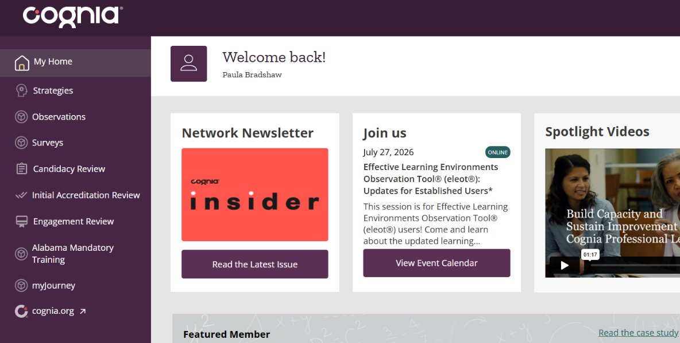
Step 4: Locate the Learning Labs. Click in the “waffle” icon at the top of the main dashboard to locate the lab Search Bar. Type in the first few words of the Learning Lab that you are choosing to complete and click the “search” icon. Select the title of the lab to access the content. Be sure the title has 2026-27 in it.
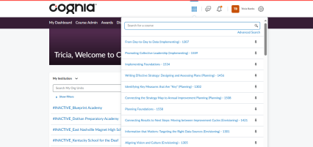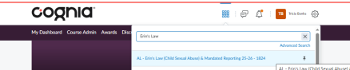
Step 5: Navigate through each section of the lab to complete. Don’t forget to bookmark home.cognia.org to access the training labs and other resources available within the Cognia Improvement Platform. If you have any technical issues, please contact alclientcare@cognia.org
Sincerely,
The Cognia Learning Community Team
Need help? Contact Cognia
alclientcare@cognia.org

