Alabama Mandatory Training Library
Completion Instructions for the Required Trainings
in the Cognia Learning Community
Teachers - Fall 2023

Greetings,
Cognia, in conjunction with the ALSDE, has developed eight learning labs (modules) in order to fulfill the state requirements regarding the knowledge and training associated with the laws and acts listed below. The Alabama Mandatory Training Library includes the following labs:
- Annalyn’s Law (Juvenile Offenders)
- Jamari Terrell Williams Act (Bullying Prevention)
- Erin’s Law (Sexual Abuse) and Mandated Reporting
- Suicide Prevention
- Understanding Gifted Students and the Gifted Referral Process
- Acceleration Procedures (Gifted)
- Addressing Disproportionality in AL Public Schools (Lee vs. Macon): Component 1 & 2: Behavior & Classroom Management
- Addressing Disproportionality in AL Public Schools (Lee vs. Macon): Component 3: Make Sense Strategies (MSS) Training
Our district/school has chosen to take advantage of these training labs. They can be accessed within the Cognia Learning Community, an asynchronous platform designed to provide an innovative professional learning experience that includes relevant, differentiated content available to all educators. To access this library, follow the directions below.
Step 1: If you do not already have an account, Cognia will send you an email to register for Cognia Home.
Step 2: Refer to the Create Your Cognia Home Account User Guide for step-by-step registration instructions.
Step 3: Navigate to the Cognia Learning Community. From the Cognia Home portal, choose one of the two options below to access the Learning Community platform.

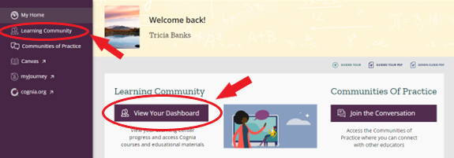

Step 4: Locate the Mandatory Training Library. Choose Learning Libraries from the left navigation panel. Choose the Alabama Mandatory Training Library 2023-24 to get started exploring the eight Learning Labs available.

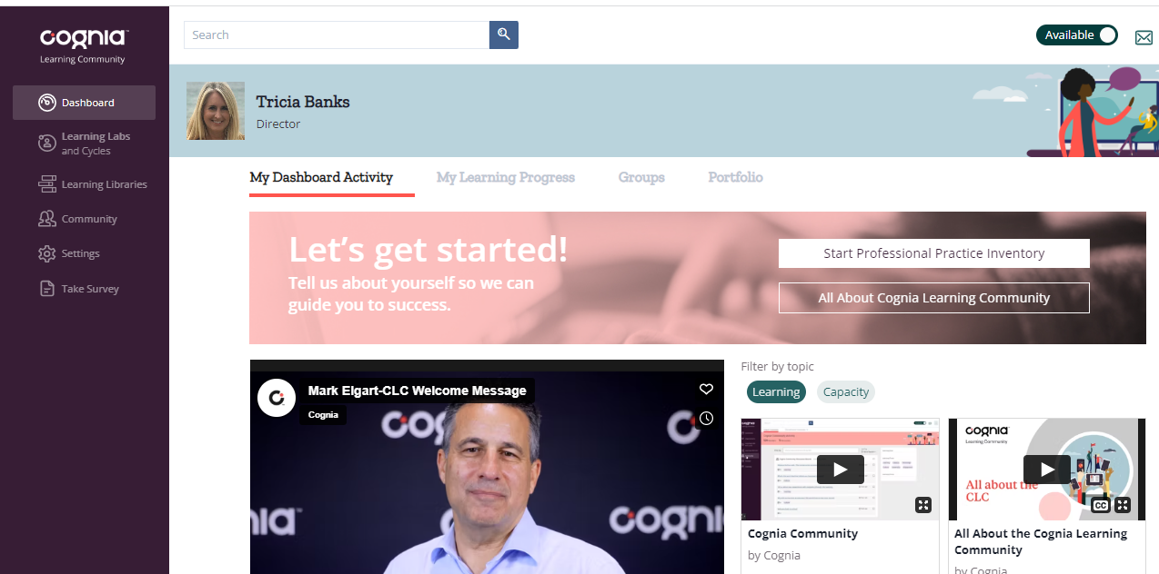

Step 5: Learning Lab Instructional Video. Watch this quick video providing an overview of how to navigate through a learning lab and complete each section.

Don’t forget to bookmark home.cognia.org to access the training labs and other resources available within the Learning Community. If you have any technical issues, please contact Cognia’s Client Care department.

Sincerely,

XXX (school leader’s name here)

Need technical assistance? Contact Cognia
clientcare@cognia.org

